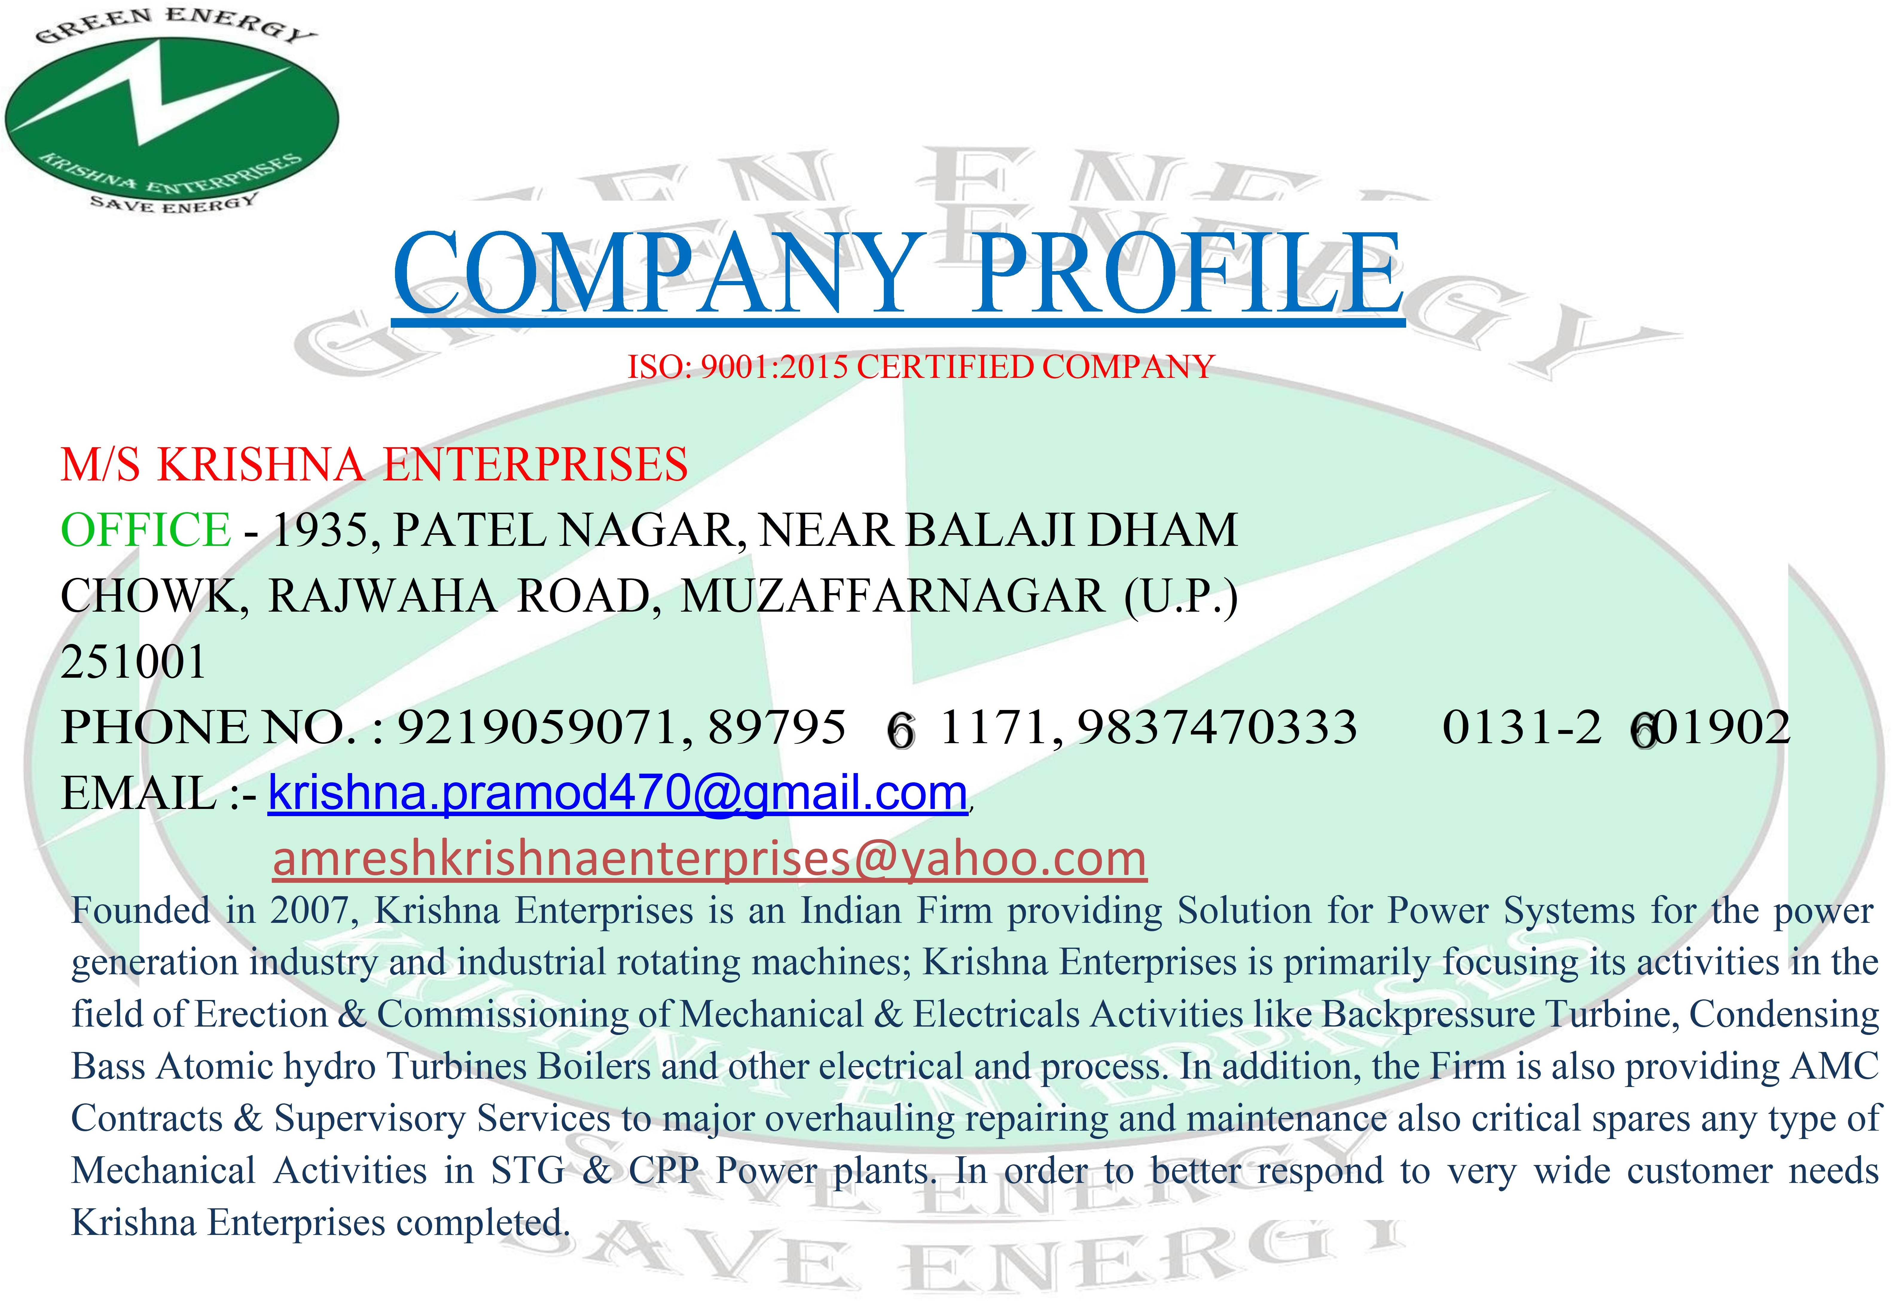

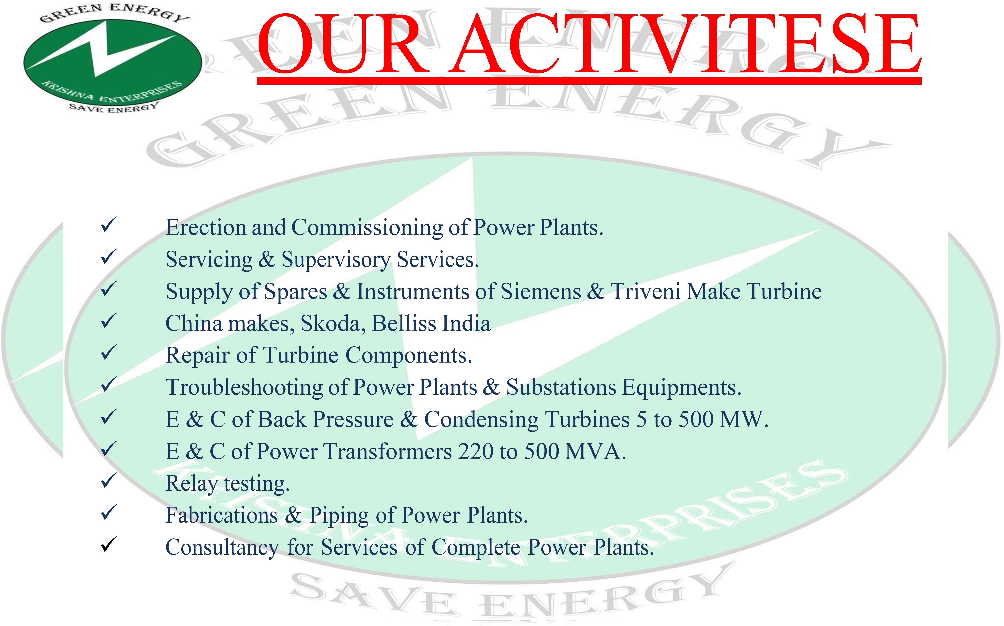



COMPANY DOCUMENTS

* Pan No.- AOFPA2133R
* GSTIN.- 09AOFPA2133R1ZU
* Registration No.- 14/ECI/R-ST/MZN-I/09
* E.S.I.C. No.- 67/N/Noida/SRO/NC/67-00-024785-000-1001
* P.F. No.- MR/MRT/0056829/000/2012-13/99415
* MSME No.- UP58E0006941

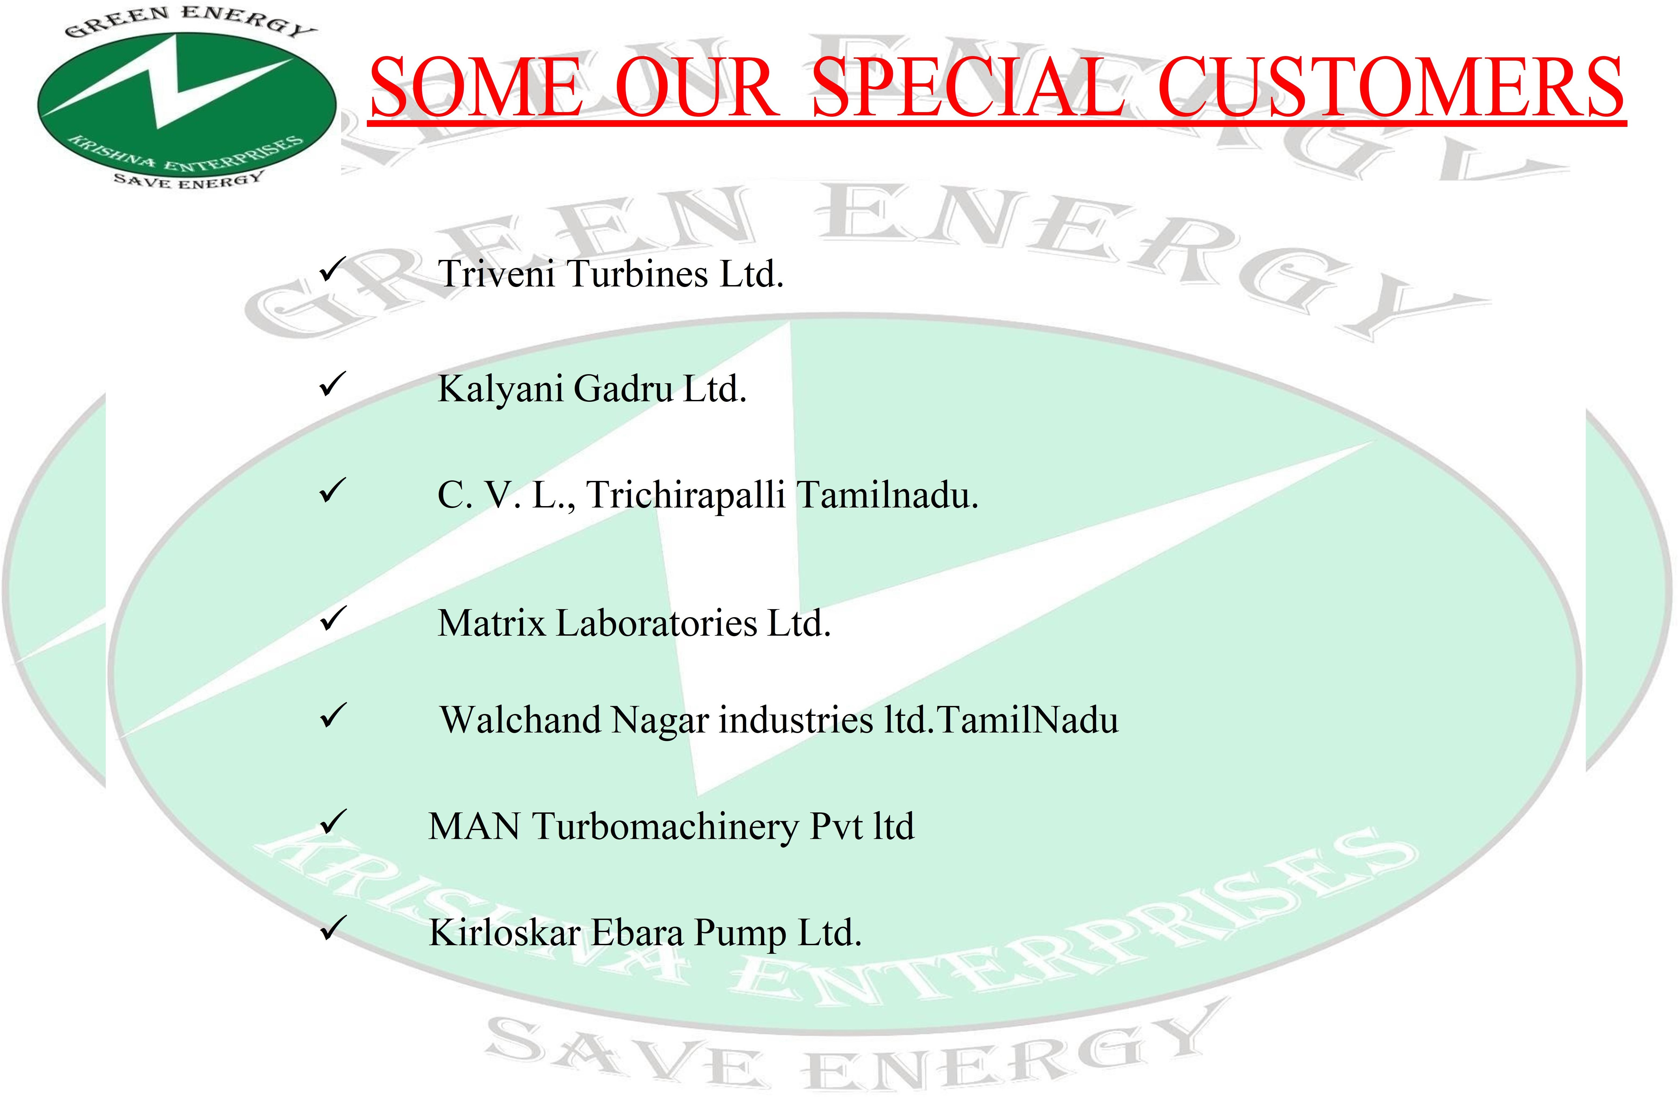

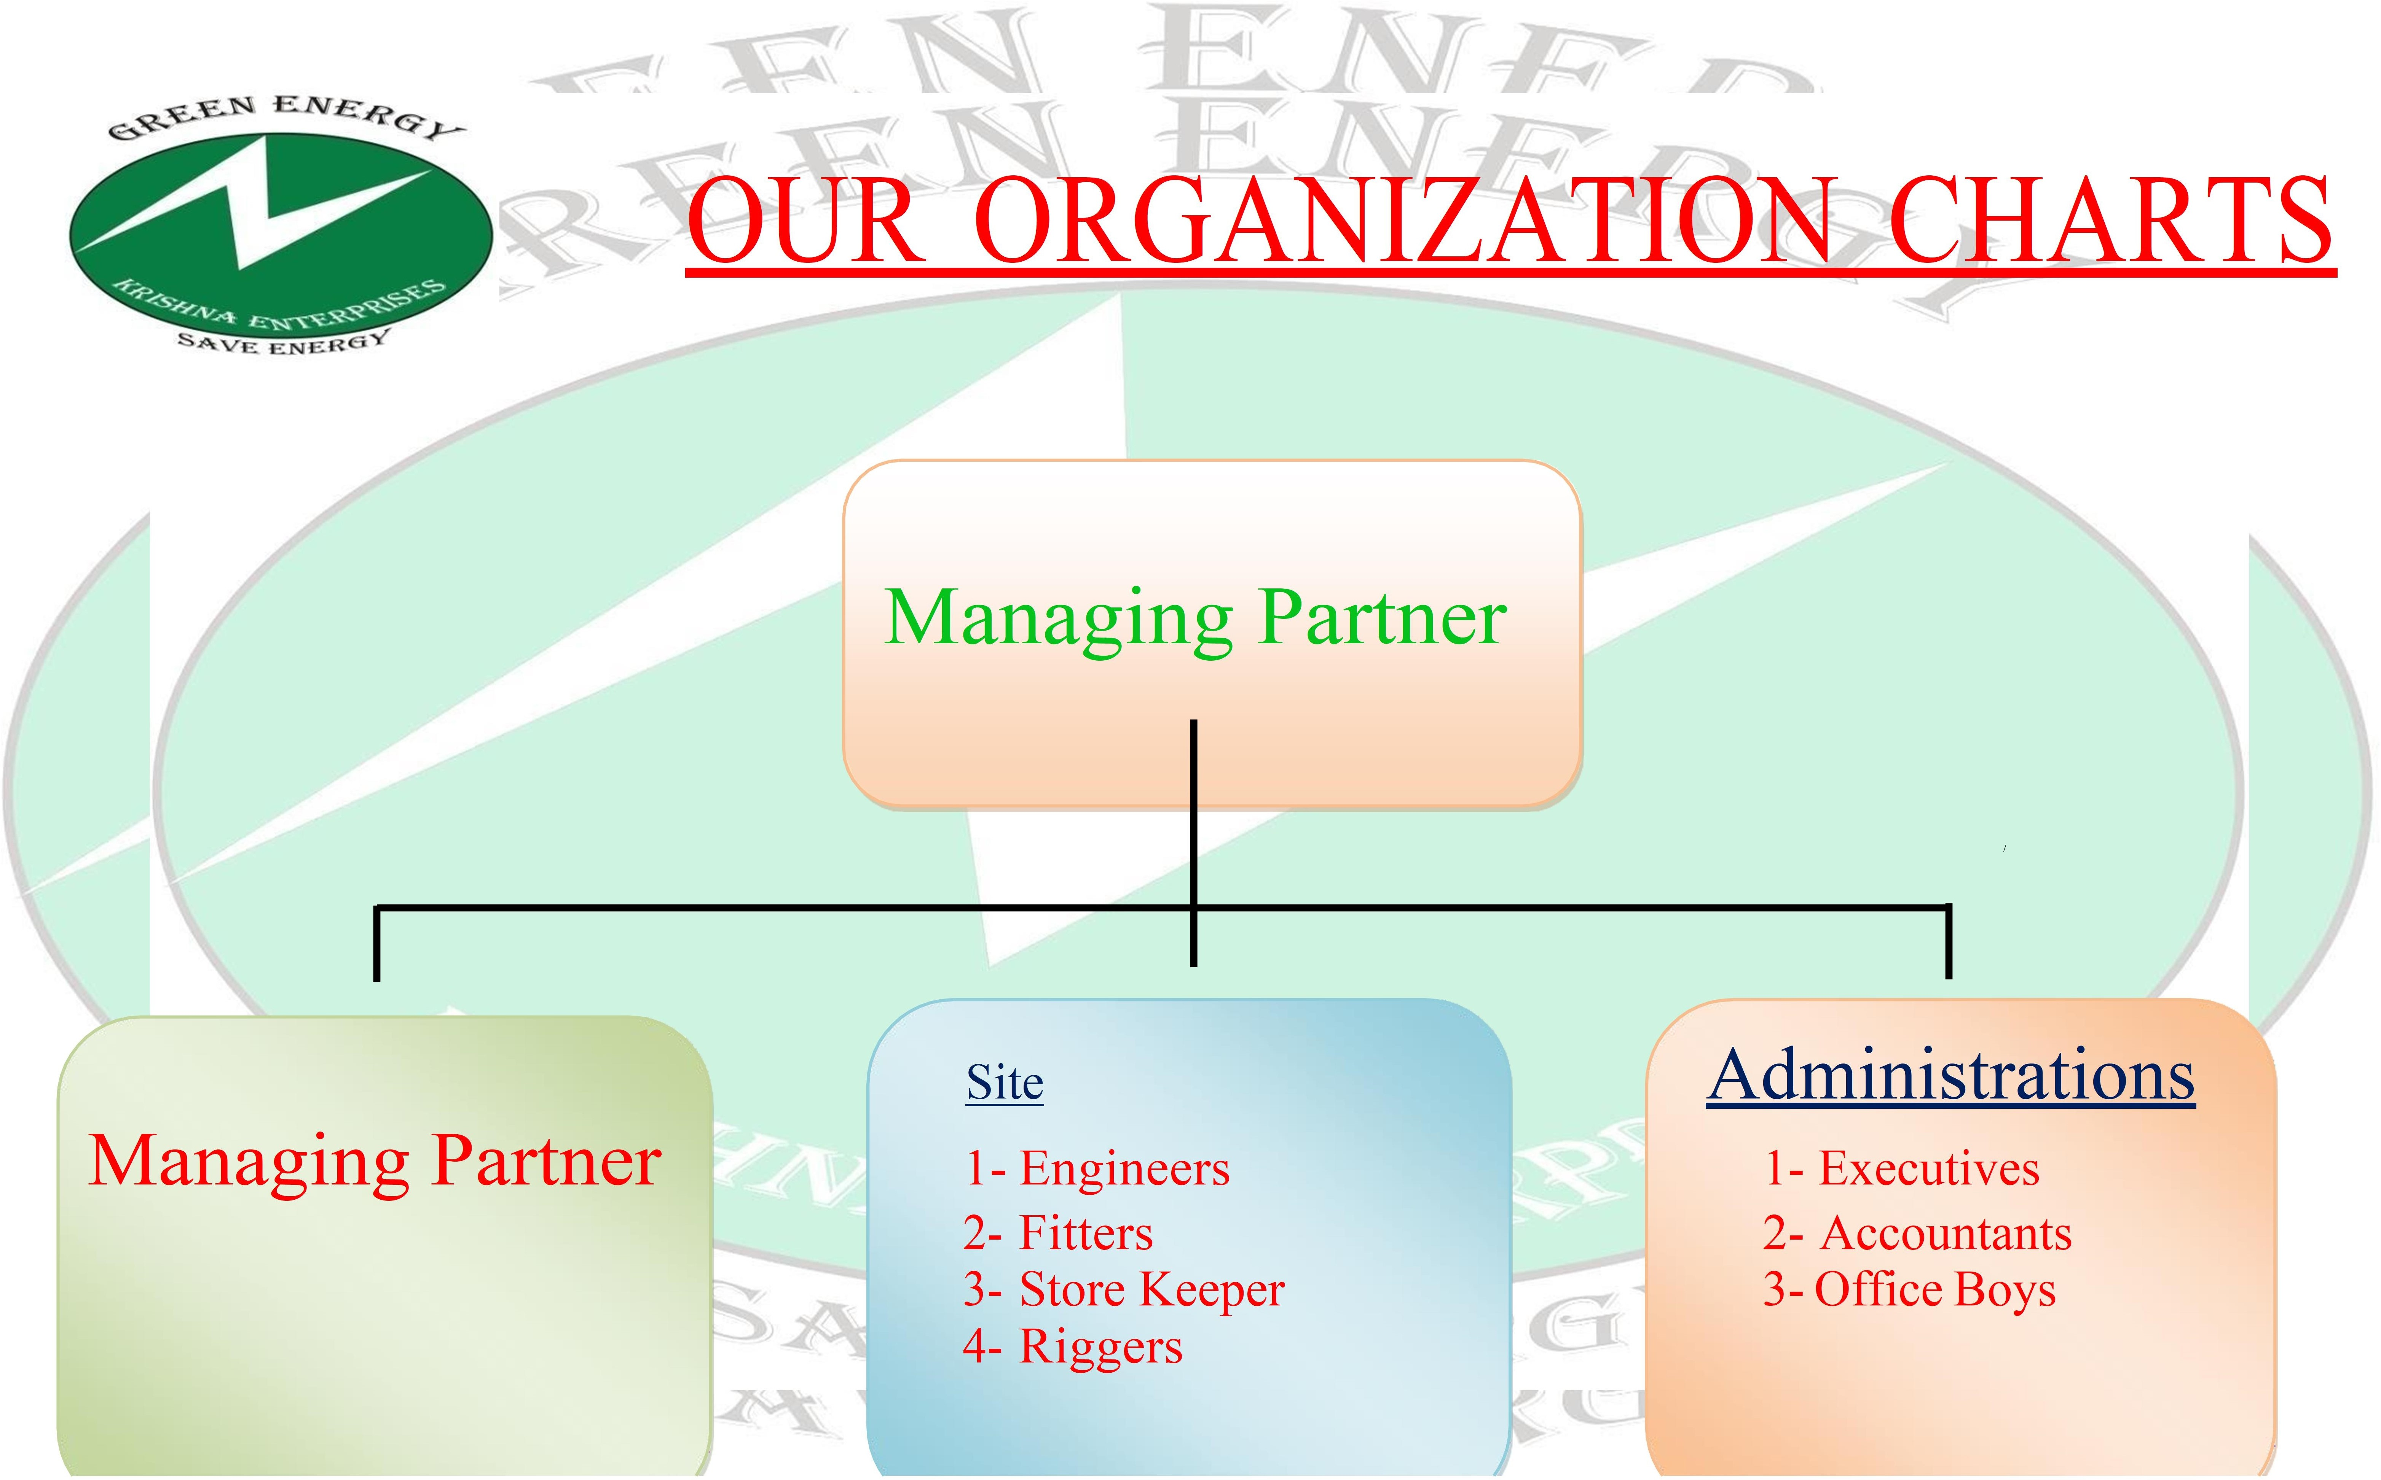



As a reputed service provider, we utilize adequate resources and technologically advanced facilities in rendering cost effective services that includes:

* + E.P.C. of complete power plant.
  + Sale purchase of old & new steam turbine.
  + Erection & Commissioning of complete power plants.
  + Operation & Maintenance of complete power plant.
  + Over hauling, Re-rating & upgrading of steam turbine.
  + Monitoring of steam turbine parameter like vibration, etc.

# CLIENT SATISFACTION

Our client centric approach makes us to deliver our clients with utmost quality and value added service so as to gain a secured position on their preference list. The impeccable quality services coupled with our customization & flexibility with our clients & their expectations made our goodwill as best service provider in the market which has helped us to gain an edge over other market.

# OUR MOTTO

Meet customer satisfaction, budget and preferences. Deliver 100% results.

Maintain Integrity and fair workmanship in all matter.

Interaction with the clients as and when required offering customer service, site call, manpower arrangement

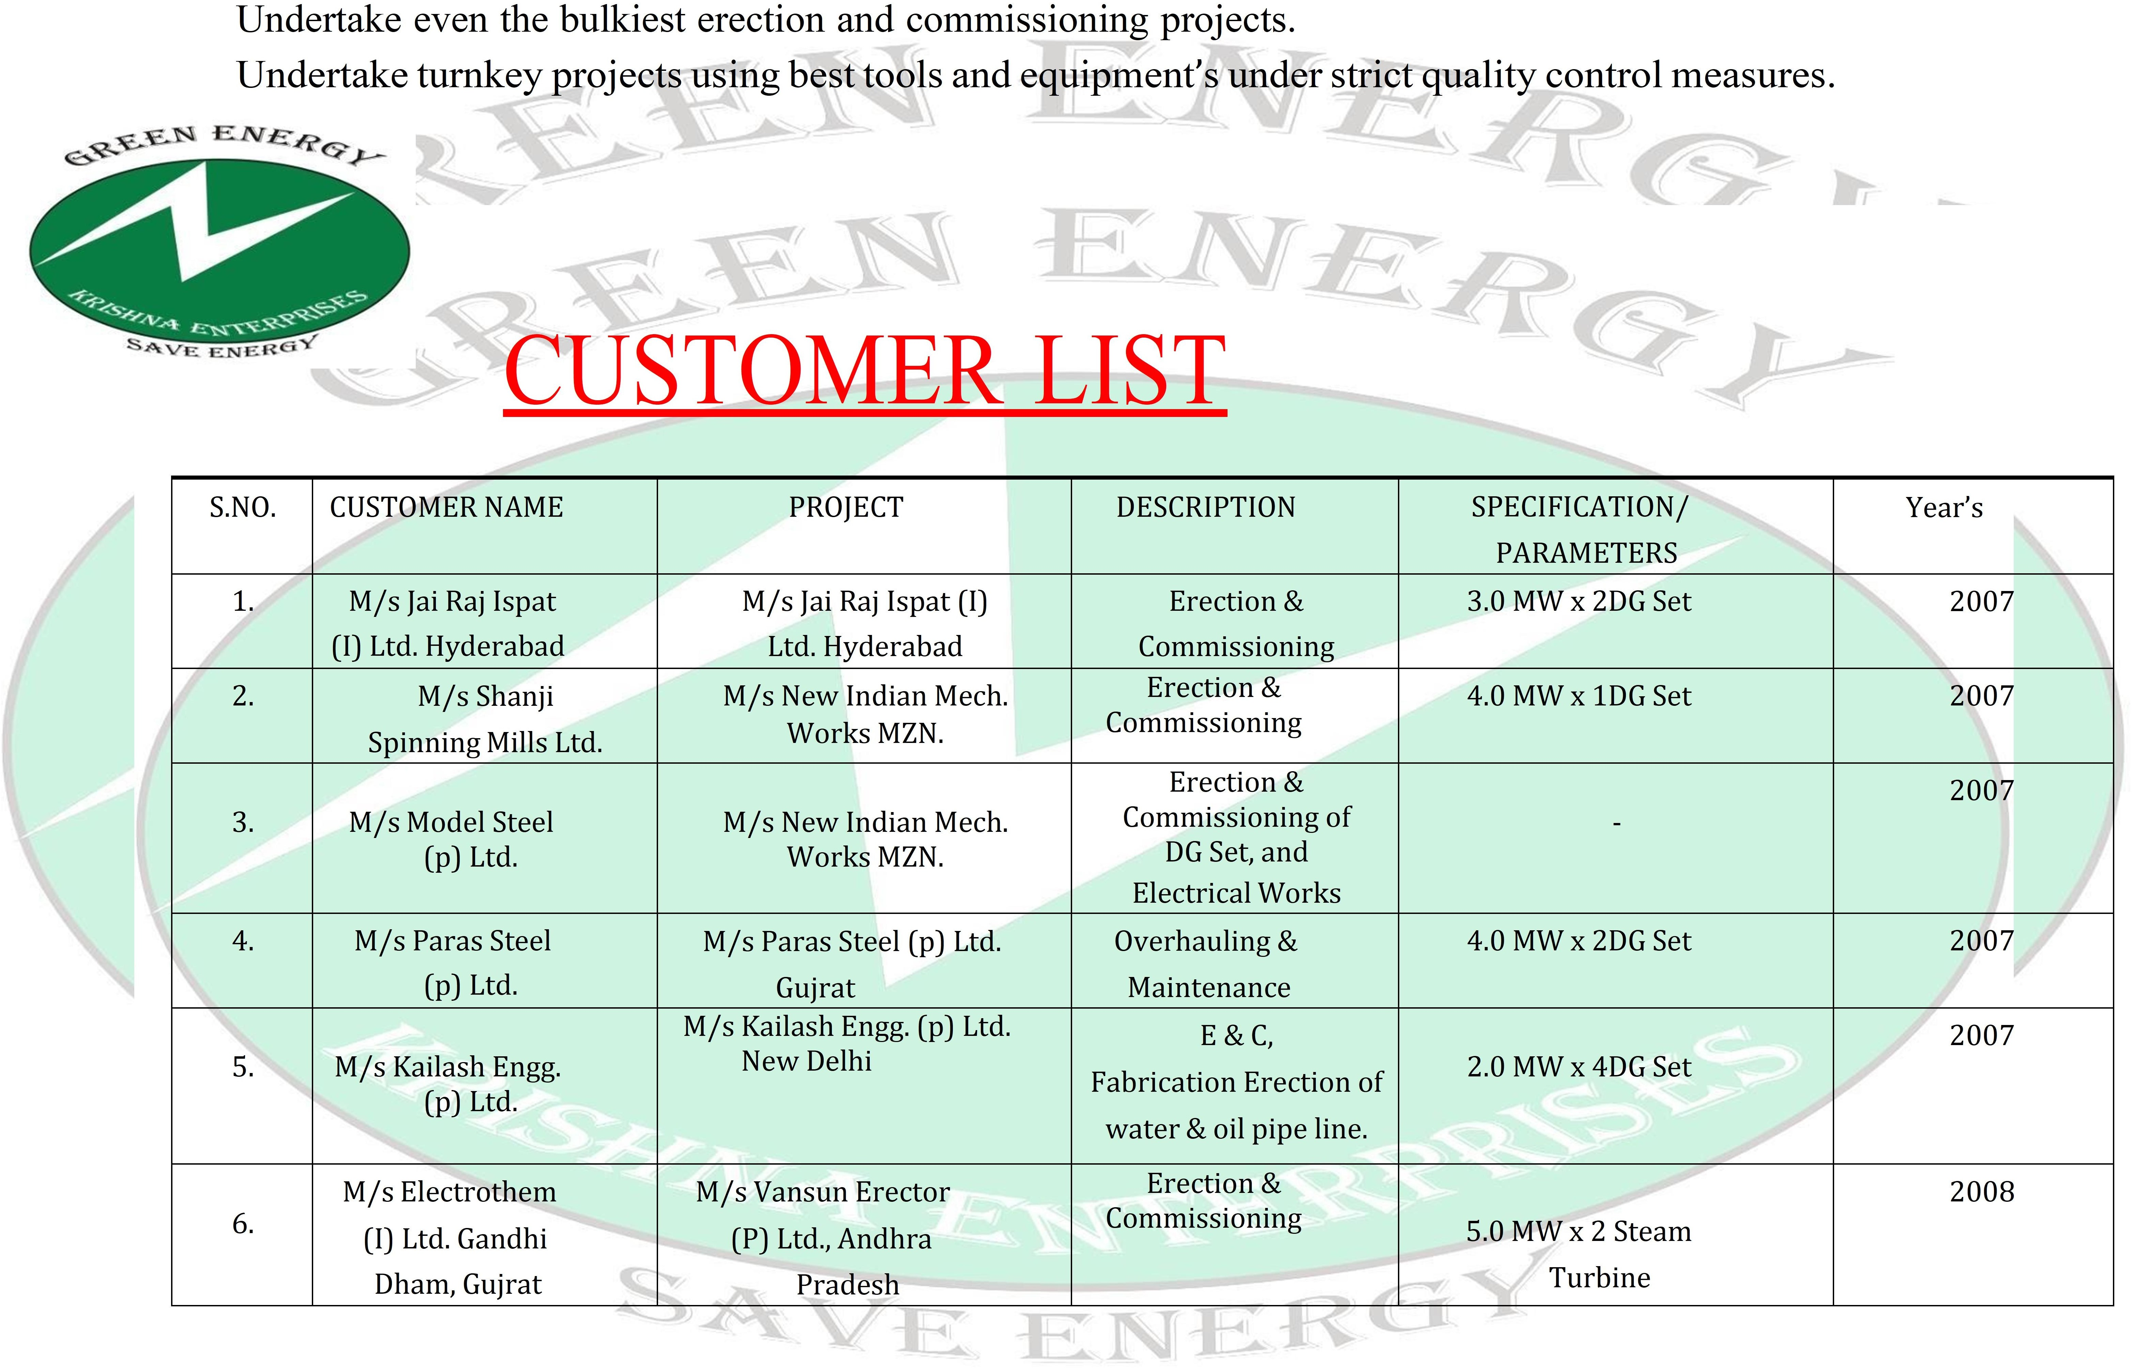

|  |  |  |  |  |  |
| --- | --- | --- | --- | --- | --- |
| 7. | M/s Electrothem  (I) Ltd. Gandhi | M/s Electrotherm (I) Ltd.  Gandhi Dham, | Cooling Tower  Erection & | - | 2008 |
| 8. | M/s Bajaj Hindustan Ltd.  Lakhimpur | M/s S .R. Engineers,  Ghaziabad | Erection & Commissioning | 3.0 MW x 1 & 2.0 MW x1MW  Steam Turbine,  Make | 2008 |
| 9. | M/s Dwarikesh Sugar Mills, Bareilly | M/s S R EngineeringGhaziabad | Non-IBR  Pipeline, Oil Piping, Fabrication,  Erection & Hydro test. | 24.0 MW x 1, Make  Siemens | 2008 |
| 10. | Vardhman Fabric Ltd. | M/S RG Engg, New Delhi | Erection &  Commissioning | 24.0 MW x 1 TDPS | 2008 |
| 11. | M/s Electrotherm  (I) Ltd. Gandhi Dham, Gujrat | M/s Electrotherm (I) Ltd.  Gandhi Dham, Gujrat | Non-IBR  Pipeline, Oil Piping, Fabrication,  Erection | 30.0 MW x 1 | 2008 |
| 12. | M/s Gulshan Sugar & Chemicals, Muzaffarnagar | M/s Gulshan Sugar & Chemicals, Muzaffarnagar | Boiler Shed, Roof Shed & Conveyor  Fabrication & Erection | - | 2008 |
| 13. | M/s Gulshan Sugar & Chemicals, HP | M/s Gulshan Sugar & Chemicals, HP | Complete Fabrication & Erection, HP &  LP and Tank Erection | 1500 Ton | 2008 |
| 14. | M/s Sidhbali paper Mill (P) Ltd.  Muzaffarnagar | M/s Sidhbali paper Mill  (P) Ltd.  Muzaffarnagar | Erection & Commissioning | 2.0 MW x 1 | 2009 |
| 15. | M/s Ramnik Power & Alloys  (P) Ltd, MP | S.R. Turbo GZB | IBR & Oil Pipeline, Fabrication, | 6.0 MW x 1 Make Triveni | 2009 |



|  |  |  |  |  |  |
| --- | --- | --- | --- | --- | --- |
| 16. | Kranti S.S.K. | S.R. Turbo GZB | Erection &  Commissioning | 8.85 MW x 1 Make  Siemens | 2010 |
| 17. | Nahar Fabrics | S.R. Turbo GZB | Erection &  Commissioning | 12.0 MW x 1 Make  Siemens | 2010 |
| 18. | Topcem Cement Ltd. | S.R. Turbo GZB | Erection &  Commissioning | 10.0 MW x 1 Make  Siemens | 2010 |
| 19. | Matrix  Laboratories Ltd. | TIEL | Erection &  Commissioning | 3.0 MW x 1 Make TIEL | 2010 |
| 20. | MCL Meghaliya | S.R. Engg. GZB. | Calling Tower  BM Plant MCW, ACW | 10.0 MW x 1 Make  Siemens | 2010 |
| 21. | MVNL Vardha | S.R. Turbo GZB. | Erection &  Commissioning | 10.0 MW x 1 Make  Siemens | 2010 |
| 22. | S.S. Fero alloys Pvt. Ltd. Meghaliya | TIEL | Erection & Commissioning | 10.0 MW x 1 TIEL | 2011 |
| 23. | Vijay Nagar sugar Pvt.  Ltd, Gadag | TIEL | Erection & Commissioning | 4.0 MW x 1 Make TIEL | 2011 |
| 24. | Vijay Nagar Bio- tech Pvt. Ltd. Vijay  Nagar, AD. | TIEL | Erection & Commissioning | 3.0 MW x 1 Make TIEL | 2011 |
| 25. | Kalyani Steel Ltd  Tadipatri, AP | TIEL | Erection &  Commissioning | 6.0 MW x 1 Make TIEL | 2011 |
| 26. | Basudha Udhyog Pvt.  Ltd.  Gumidipoondi Channai | TIEL | Erection & Commissioning | 10.0 MW x 1 Make TIEL | 2011 |



|  |  |  |  |  |  |
| --- | --- | --- | --- | --- | --- |
| 27. | Shyam Cell  Asansol | Siemens | Erection &  Commissioning | 18.0 MW x 1 Make  Siemens | 2012 |
| 28. | Aryan Ispat | TIEL | Erection &  Commissioning | 18.0 MW x 1 Make TIEL | 2012 |
| 29. | KCP POLLACHI  TAMILNADU | C. V. L. | Erection &  Commissioning | 10MW x 1 Make  Siemens | 2012 |
| 30. | Ankur Bio Cem. | T. T. L. | Erection &  Commissioning | 2.5 MW x 1 Make T.T.L | 2013 |
| 31. | Sajjan India Ltd, Ankhleshwar Gujrat | T.T.L. | Erection & Commissioning | 2.5 MW x 1 Make T.T.L | 2013 |
| 32. | Godrej Oil Palm.  Ltd, W.Godawri | T.T.L. | Erection & Commissioning | 2.5 MW x 1 Make T.T.L | 2013 |
| 33. | 3Fo Palm Oil Pvt. Ltd. | TTL | Erection & Commissioning | 3MW | 2013 |
| 34. | Alok Ind. Ltd. Vapi  Gujrat | T.T.L. | Erection &  Commissioning | 2.8 MW x 1 Make T.T.L | 2013 |
| 35. | Mata Energy Ltd., Nal  Gonda, A.P. | T.T.L. | Erection &  Commissioning | 10 MW x 1 Make T.T.L | 2013 |
| 36. | Ruchi Soya Ltd.  Palm Oil Division, Pedda Puram, A.P. | T.T.L. | Erection & Commissioning | 3 MW x 1 Make T.T.L | 2013 |
| 37. | The Kallakurchi, Ist Co.O, Moogil vellupuram, tamilnadu perative, Sugar Mill | T.T.L. | Erection & Commissioning | 15 MW x 1 Make T.T.L | 2014 |
| 38. | The Kallakurchi, IInd Co.Operative, Sugar Mill, Kallakurchi, vellupuram,  tamilnadu | T.T.L. | Erection & Commissioning | 15 MW x 1 Make T.T.L | 2014 |



|  |  |  |  |  |  |
| --- | --- | --- | --- | --- | --- |
| 39 | The selam co.oprative sugar mill, Moganur, namankkal dist,  tamilnadu | T.T.L. | Erection & Commissioning | 15 MW x 1 Make T.T.L | 2014 |
| 40. | C.M.J. Brawraise Ltd., Meghalaya | T.T.L. | Erection & Commissioning | 4 MW x 1 Make T.T.L | 2014 |
| 41. | Shri Shakumbri Ferro alloys | T.T.L. | Erection & Commissioning | 10 MW x 1 Make T.T.L | 2014 |
| 42. | Gold Stone Cement Ltd,  Jaintia Hills Dist, Meghalaya | T.T.L. | Erection & Commissioning | 12 MW x 1 Make T.T.L | 2014 |
| 43. | Cetex petrochemicals ltd channai | TTL | Erection & Commissioning | 2.5 M.W x 1 Make T.T.L | 2014 |
| 44. | M/S SPY Agro ltd  Nandyal | T.T.L | Erection & Commissioning | 6.45 M.W x 1 Make T.T.L | 2015 |
| 45. | M/S Redan Infrastucture pvt Ltd Gangavaram | T.T.L | Erection & Commissioning | 8 M.W x 1 Make T.TL | 2015 |
| 46. | Godrej Oil Palm.  Ltd, W.Godawri | T.T.L | Erection & Commissioning | 5.MW | 2015 |
| 47. | Rajlakshmi Paper Mills Ltd. Palani T.N | T.T.L | Erection & Commissioning | 2.5 M.W x 1 Make TTL | 2015 |
| 48. | Bhramputra Biocem Pvt. Ltd. (Asam) | TTL | Erection & Commissioning | 3MW | 2015 |
| 49. | M\S EID PARRY INDIA LTD HALIYAL  KARNATAKA | T.T.L | Erection & Commissioning | 7 M.W x 1 Make TTL | 2015 |
| 50. | Daund Sugar’s Ltd | TTL | Erection &  Commissioning | 4.05M.W x1 Makes TTL | 2015 |
| 51. | Rafbrix Pvt. Ltd | Rafbrix Pvt. Ltd | O&M | 3 TON Boiler | 2015 |
| 52. | M/S SVP Industries LTD | TTL | Erection &  Commissioning | 2.7MW X1 Makes TTL | 2015 |



|  |  |  |  |  |  |
| --- | --- | --- | --- | --- | --- |
| 53. | M/S Bharmputra  Biotech pvt ltd | TTL | Erection &  Commissioning | 2.MW X1 Makes TTL | 2015 |
| 54. | Raichur Bio Energies  pvt ltd | TTL | Erection &  Commissioning | 9MW X1 Makes TTL | 2015 |
| 55. | Thermal power system  a/c MAPL | TTL | Erection &  Commissioning | 5MW X1 Makes TTL | 2015 |
| 56. | Veda biofuel ltd | TTL | Erection &  Commissioning | 3MW X1 Makes TTL | 2015 |
| 57. | GSCL | GSCL | O&M | 12 MW | 2016 |
| 58. | M\S PREMIER ORGANICS PVT  LTD Nepal | Maxwatt Turbines ltd | Erection & Commissioning | 1.2MW X1 Makes MTL | 2016 |
| 59. | CG Brewery pvt ltd Nepal | MAN Turbomachinery Pvt  Ltd | Erection & Commissioning | 2.2MW X1 Makes MTPL | 2016 |
| 60. | INDRESHWAR  SUGERS LTD. SOLAPUR | TTL | Erection & Commissioning | 1.8MW X1 Makes TTL | 2016 |
| 61. | ATHANI SUGERS LTD. ATHANI | TTL | Erection & Commissioning | 5.6MW X1 Makes TTL | 2016 |
| 62. | APPLE INDUSTRIES LTD | TTL | Erection & Commissioning | 12 MW X1 Makes TTL | 2016 |
| 63. | DHAMPUR SUGAR MILL,  ASMOLI | MAN Turbomachinery Pvt  Ltd | Erection &  Commissioning | 8.050MW X1 Makes MTPL | 2016 |
| 64. | Godavari  Biorefineries Ltd | TTL | Erection &  Commissioning | 4.015MW x 1 Make TTL | 2016 |
| 65. | Suraj Product Ltd | MAN Turbomachinery Pvt  Ltd | Erection &  Commissioning | 6 MW X1 Makes MTPL | 2016 |



|  |  |  |  |  |  |
| --- | --- | --- | --- | --- | --- |
| 66. | PRAJ INDUSTRIES PVT LTD. | MAN ENERGY SOLUTION | Erection & Commissioning | 2830 KW | 2017 |
| 67. | SHREE GLUCO BIOTECH PVT  LTD | TTL | Erection & Commissioning | 3.7 MW X1 Makes TTL | 2017 |
| 68. | SUTLAJ TEXTILES INDUSTRIES LTD. | BIRLA GROUP | OVERHAULING | 12.MW Makes TTL | 2017 |
| 69. | TS Co-op Oil Seeds Growe | TTL | Erection &  Commissioning | 2 MW X1 Makes TTL | 2017 |
| 70. | 3F OIL PALM AGROTECH PVT  LTD | TTL | Erection & Commissioning | 2 MW X1 Makes TTL | 2017 |
| 71. | GOOD YEAR  INDIA LTD | KEPL | Erection &  Commissioning | 250 KW X1 Makes KEPL | 2017 |
| 72. | EMMERNNR PHARMA PVT LTD | TTL  MAN DIESEL& TURBO IND.PVT.LTD.  BANGALORE | Erection & Commissioning | 4.8 MW X1 Makes TTL | 2017 |
| 73. | SAINT GOBIN JHAGDIA | OVERHAULING | 3.2 MW | 2017 |
| 74. | KBK BIOTECH PVT LTD. | MAN DIESEL& TURBO  IND.PVT.LTD. BANGALORE | Erection & Commissioning | 1.5 MW | 2018 |
| 75. | THE PRAM BALUR COPERATIVE SUGAR  MILL. | TTL | OVERHAULING | 18 MW | 2018 |
| 76. | GOBIND SUGAR MILL, PHILIBHIT | MAN ENERGY SOLUTION | MAN POWER SUPPLY (E&C) | 6MW | 2018 |



77

|  |  |  |  |  |  |
| --- | --- | --- | --- | --- | --- |
| 77. | THE DHARMPURI COPERATIVE SUGAR MILL | TTL | Erection & Commissioning | 15 MW  8 MW | 2018  2018 |
| 78. | COVALENT LAB. PVT LTD. | TTL | Erection & Commissioning |
| 79. | MRN POWER BATHAMI BHAGALKOT | TTL | Erection & Commissioning | 30 MW | 2018 |
| 80. | PRAJ INDUSTRIES PVT LTD. | MAN ENERGY SOLUTION | Erection & Commissioning | 2830 KW | 2018 |
| 81. | Renuka Sugar Mill Unit-6 Athani | TTL | Erection & Commissioning | 8 MW | 2018 |
| 82. | Renuka Sugar Mill Unit-5 Afzalpur | TTL | Erection & Commissioning | 8 MW | 2019 |
| 83. | TULSI PAPER MILL SURAT | MAN ENERGY SOLUTION | Erection & Commissioning | 4800 KW | 2019 |
| 84. | Bannari Amman Sugar Mill, Mysore | TTL | Erection & Commissioning (Process) | 6 MW | 2019 |
| 85. | JINDAL URBAN WASTE MANAGMENT | TTL | Erection & Commissioning | 20 MW | 2019 |
| 86. | GEM SUGERS LTD. | MAN TURBO | Erection & Commissioning | 3MW | 2019 |
| 87. | Vishnu vishal paper mill, muradabad | VVPL | OVERHAULING | 12 MW | 2019 |



|  |  |  |  |  |  |
| --- | --- | --- | --- | --- | --- |
| 88. | Arinagar anna sugar mill, Thanjavur T.N. | Walchand nagar industries ltd. | OVERHAULING | 15 MW | 2019 |
| 89. | MURLI MOHANA BOILED RICE MILL | TTL | Erection & Commissioning | 4.85 MW | 2019 |
| 90. | M\S EID PARRY INDIA LTD BAGALKOT  KARNATAKA | T.T.L | Erection & Commissioning  (Process) | 3 M.W x 1 Make TTL | 2019 |
| 91. | THE NANDI SSK LTD BILGI, VIJAYPURA, KARNATAKA | T.T.L | Erection & Commissioning  (Process) | 3 M.W x 1 Make TTL | 2019 |
| 92. | MRN POWER LTD. KULGERI, BAGALKOT KARNATAKA | T.T.L | Erection & Commissioning  (Process) | 8 MW | 2020 |
| 93. | SIDDHAPUR DISTLL. LTD. | GOT.T.L | Erection & Commissioning | 3 MW | 2020 |
| 94. | ANDHRA ORGANICS LTD. VISHAKAPATNAM | T.T.L | Erection & Commissioning | 4.5MW | 2020 |
| 95. | Genus Paper & Board Pvt Ltd | Genus Paper & Board Pvt Ltd | Supply of S.S Condensing Tubes & Pipe Lines | 9 MW | 2020 |
| 96. | Bilagi Sugar Mill Limited, | T.T.L | Erection & Commissioning | 4.5MW | 2020 |
| 97. | Vaibhav Industries Latur | T.T.L | Erection & Commissioning | 2 MW | 2020 |



|  |  |  |  |  |  |
| --- | --- | --- | --- | --- | --- |
| 98. | Shri Ayya Hi-Tech Modern Rice Mill, Vallamputhur | T.T.L | Erection & Commissioning | 0.75 MW | 2020 |
| 99. | Harsha Sugars Ltd.  Belgaon. | T.T.L | Erection & Commissioning | 3MW | 2021 |
| 100. | *M*/S SHREE RENUKA SUGARS LTD*.*  *AFZALPUR* | TTL | Erection & Commissioning | 8MW | 2021 |
| 101. | PLA Foods Pvt. Ltd.  Rudrapur. | PLA | Turbine Overhauling | 1 MW | 2021 |
| 102. | DEE VEE Powers Ltd. | DEE VEE | Erection& Commissioning | 3MW | 2021 |
| 103 | *M*/S SHREE RENUKA SUGARS LTD*.*  *ATHANI* | TTL | Erection& Commissioning | 9MW | 2021 |
| 104. | M/S RANA SUGARS LIMITED | Rana sugar | Erection& Commissioning | 9.85 MW | 2021 |
| 105. | BUTTER BIOFUEL PVT LTD. | Rana sugar  MAN  TTL | Erection& Commissioning | 9 MW | 2021 |
| 106. | PCBL | Erection& Commissioning | 7.28MW | 2021 |
| 107. | *M*/S SHREE RENUKA SUGARS LTD*.*  *MANOLI* | Erection& Commissioning | 8.5 MW | 2021 |
| 108. | GODAVARI BIOREFINERIES LTD. | TTL | Erection& Commissioning | 10 MW | 2022 |
| 109 | G.M SUGERS MILL | TTL | Erection& Commissioning | 2.25MW | 2022 |
| 110. | HARSHA SUGAS LT. | TTL | Erection& Commissioning | 2.5 MW | 2022 |
| 111. | SHIV SHAKTI SUGARS HERMES DISTT. LTD. | TTL | Erection& Commissioning | 17 MW | 2023 |
| 112. | M\S EID PARRY INDIA LTD HALIYAL  KARNATAKA | TTL | Erection& Commissioning | 3.MW | 2023 |



|  |  |  |  |  |  |
| --- | --- | --- | --- | --- | --- |
| 113. | NAV BHARAT LTD. | MAN ENERGY SOLUTION | Erection& Commissioning | 7.5MW | 2023 |
| 114. | KBK BIOTECH | MAN ENERGY SOLUTION  TTL | Erection&  Commissioning | 7.28MW | 2023 |
|  |  |  |  |  |
| 115. | GREEN ENERGY BIOREFINERIES LTD. | Erection& Commissioning | 9MW | 2023 |
| 116. | SENTINI BIOPRODUCTS P LTD. | TTL | Erection& Commissioning | 4.5MW | 2023 |
| 117. | JAI RAJ ISPAT | TTL | Erection& Commissioning | 12MW | 2023 |
| 118. | INDIAN CANE AND POWER LTD. | TTL | Erection& Commissioning | 8MW | 2023 |
| 119. | ANDHRA GREEN LTD. | SIMEANS | Erection& Commissioning | 3.85MW | 2023 |
| 120. | BIO CON LTD. | TTL | Erection& Commissioning | .6MW | 2024 |
| 121. | UMIAM DISTILLATION PVT LTD. | UTTAM ENERGY LTD. | Erection& Commissioning | 4.35 MW | 2024 |
| 122. | KUCTCH COPPER LTD | MAN ENERGY SOLUTION | Erection& Commissioning (Process) | 12.85MW | 2024 |
| 123. | (SPAC) STARCH PRODCUTS PVT LTD. | MAN ENERGY SOLUTION | Erection& Commissioning | 4600KW | 2024 |

|  |  |  |  |  |  |
| --- | --- | --- | --- | --- | --- |
| 124. | ADHAR GREEN INDUSTRIES LTD. | UTTAM ENERGY LTD. | Erection& Commissioning | 3.3MW | 2024 |
| 125. | NAINI PAPERS LTD. | MAN ENERGY SOLUTION | Erection& Commissioning | 20MW | 2024 |
| 126. | SNJ DISTILLERES PVT. LTD. | TTL | Erection& Commissioning | 5MW | 2025 |
| 127. | SLR METALIKS  LTD | TTL | Erection& Commissioning  (Process) | 7MW | 2025 |
| 128. | AARTI INDUSTRISES LTD. | AARTI INDUSTRISES LTD | Erection& Commissioning  (Process) | 2MW | 2025 |

